**CONNECTIONS IN WOKWI FOR ULTRASONIC SENSOR**

**CODE**

**Sketch.ino:**

/*

 Ultrasonic Simple

   Prints the distance read by an ultrasonic sensor in

   centimeters. They are supported to four pins ultrasound

   sensors (liek HC-SC04) and three pins (like PING)))

   and Seeed Studio sensors).

   The circuit:

 * * Module HR-SC04 (four pins) or PING))) (and other with

     three pins), attached to digital pins as follows:

   ---------------------    --------------------

   | HC-SC04 | Arduino |    | 3 pins | Arduino |

   ---------------------    --------------------

   |   Vcc   |   5V    |    |   Vcc  |   5V    |

   |   Trig  |   12    | OR |   SIG  |   13    |

   |   Echo  |   13    |    |   Gnd  |   GND   |

   |   Gnd   |   GND   |    --------------------

   ---------------------

 */

#include "Ultrasonic.h"

/*

   Pass as a parameter the trigger and echo pin, respectively,

   or only the signal pin (for sensors 3 pins), like:

   Ultrasonic ultrasonic(13);

*/

Ultrasonic ultrasonic(12, 13);

int distance;

void setup() {

**Serial**.begin(9600);

}

void loop() {

  // Pass INC as a parameter to get the distance in inches

  distance = ultrasonic.read(CM);

**Serial**.print("Distance in CM: ");

**Serial**.println(distance);

  distance = ultrasonic.read(INC);

**Serial**.print("Distance in Inches: ");

**Serial**.println(distance);

  delay(1000);

}

**Diagram.json:**

{

  "version": 1,

  "author": "6117_ PRATHIBA N",

  "editor": "wokwi",

  "parts": [

    { "type": "wokwi-arduino-uno", "id": "uno", "top": 88.67, "left": -30, "attrs": {} },

    { "type": "wokwi-hc-sr04", "id": "ultrasonic1", "top": -88.09, "left": -64.33, "attrs": {} }

  ],

  "connections": [

    [ "ultrasonic1:VCC", "uno:5V", "red", [ "v33.74", "h-107.21", "v292.8", "h230" ] ],

    [ "ultrasonic1:TRIG", "uno:12", "green", [ "v59.84", "h90.43", "v1.63" ] ],

    [ "ultrasonic1:ECHO", "uno:13", "magenta", [ "v69.63", "h4.25" ] ],

    [ "ultrasonic1:GND", "uno:GND.1", "black", [ "v42.72", "h51.82", "v-0.82" ] ]

  ]

}

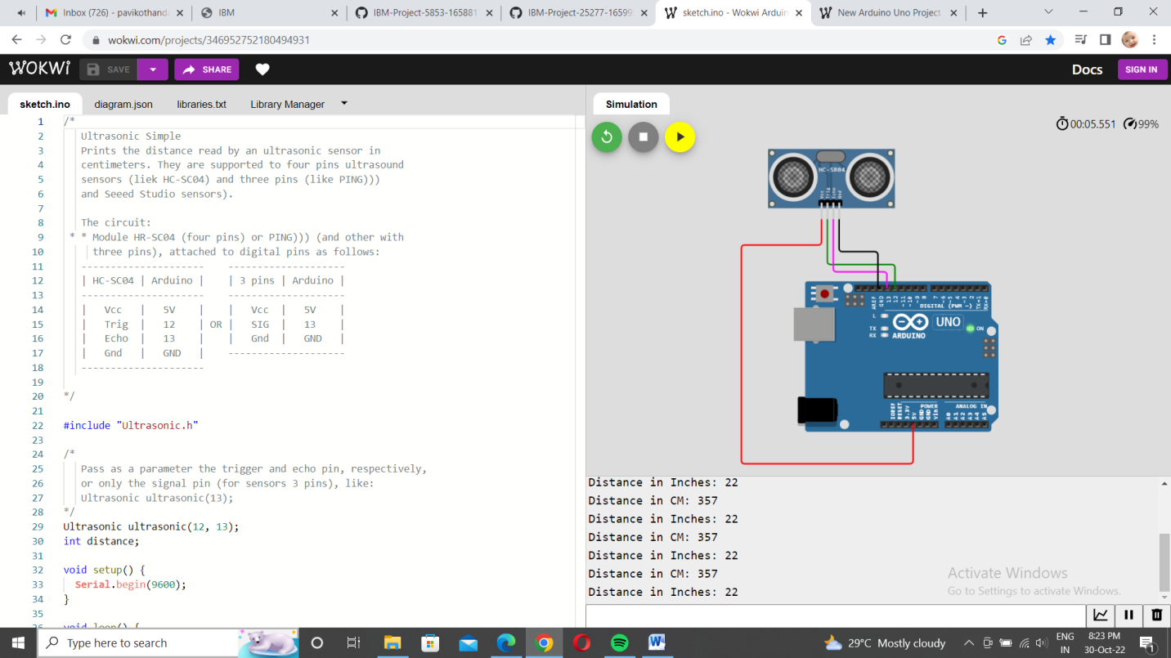

LINK: https://wokwi.com/projects/346956944762733139